# Ways to set up Run Modes

1. By quickstart jar naming convention we can set up desired run mode

***aem<optional-version-or-indentifier>-<standard-run-mode>-p<port-number>***

1. Run modes can be specified in ***sling.properties*** file(at <crx-quickstartfolder>/conf/sling.properties). Set the property, *sling.run.modes,*to a comma-delimited list of run modes to apply.

For example:

**sling.run.modes=author,test,uk**

1. We start the aem server start.script, here we can specify in start script line # 19



And in system/console we see the same thing reflecting

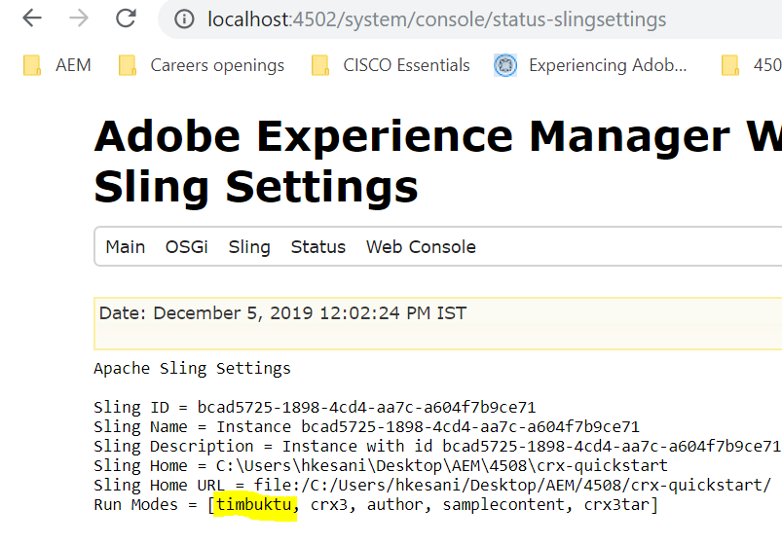

1. –r option when invoking the jar file from command prompt

Java –jar

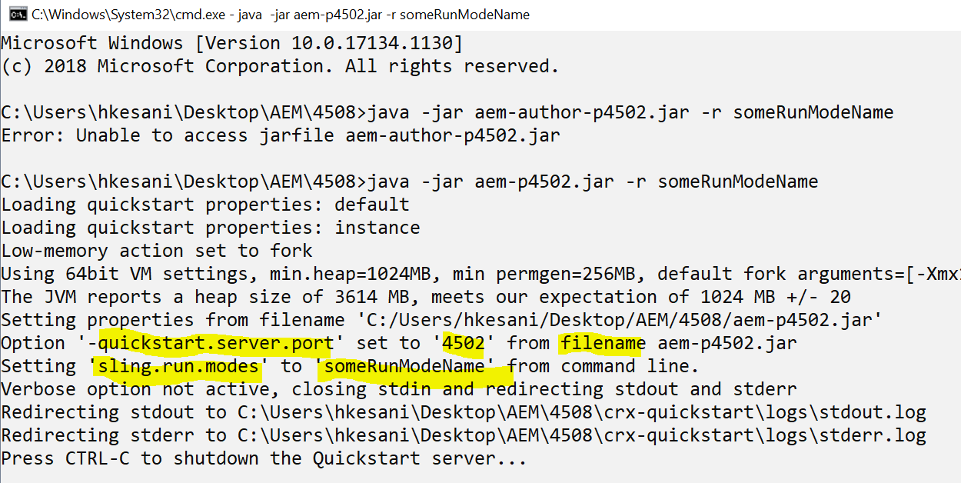

# Precedence

system properties (-D) > sling.properties file > -r option > filename detection.

If we start the instance with start.bat script file, point(3) is given the priority

If we click on jar, sling.properties will be given priority

# OOTB available run modes

* **author**
* **publish**
* **samplecontent – comes with we.retail (for reference)**
* **nosamplecontent – comes without we.retail(suitable for prod)**

These are two pairs of mutually exclusive run modes; for example, you can:

* define either author or publish, not both at the same time
* combine author with either samplecontent or nosamplecontent (but not both)

# Run mode specific configurations in repository

* **config**  
  Applicable for all run modes
* **config.author**  
  Used for author run mode
* **config.publish**  
  Used for publish run mode
* **config.<*run-mode*>**  
  Used for the applicable run mode; for example, config

Eg : in WEM , we have various configs like

Config.author.prod – applicable to instances with run modes author & prod

Config.author.dev – applicable to instances with run modes author & dev

Config.author.stage – applicable to instances with run modes author & stage

Config – applicable to all instances independent of run modes

Config.publish – to all publish instances

Config.author – to all config instances

# NOTE

Changes to configurations (config.<runMode>)in run modes will be applicable only after a node is restarted

# Loading configs based on runmodes

We can specify configurations for OSGi components in the repository with the nodes of type *sling:OsgiConfig* and the node name can be anything but preferably the PID of the component/Service

# Resolution of multiple run modes

Scenario:

Suppose we have a PID : com.day.cq.commons.impl.ExternalizerImpl

This configuration is available in all the runmode level configurations (author, prod, lt, dev,devint)

To understand which config will be picked on a particular host is defined by the highest number of matching runmodes configured on instance and the config.<runMode1>.<runMode2> file in repository

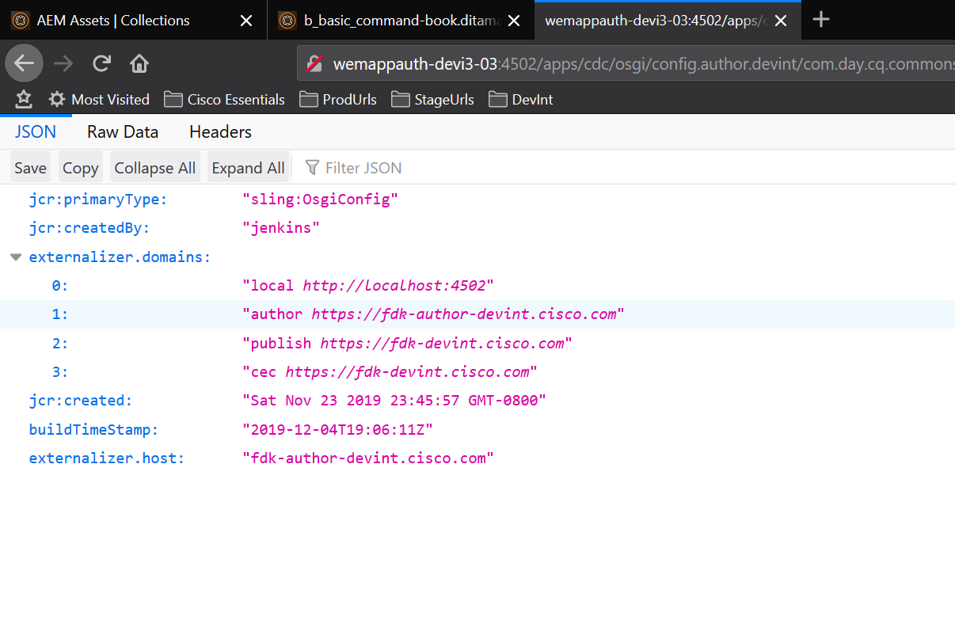

# Useful Links

Refer to **Resolution of multiple Run Modes**  - <https://helpx.adobe.com/in/experience-manager/6-3/sites/deploying/using/configuring-osgi.html?cq_ck=1368002864971#OSGiConfigurationintheRepository>